**Project Design Phase**

**Solution Architecture**

|  |  |
| --- | --- |
| Date | 20 June 2025 |
| Team ID | LTVIP2025TMID41886 |
| Project Name | TrafficTelligence: Advanced Traffic Volume Estimation with Machine Learning |
| Maximum Marks | 4 Marks |

**Solution Architecture:**

The solution architecture of this project forces on building a predictive system that estimates traffic volume using historical data and machine learning techniques. It involves collecting and preprocessing traffic model, and integrating the model into a user-friendly web application using Flask and HTML. The architecture defines the structure, behaviour, and flow of the system- from data input to prediction and visualization- ensuring that the solution is accurate, efficient, and easy to use. It provides a scalable framework that can be enhanced further with real-time data and cloud deployment in the future.

**Example - Solution Architecture Diagram:**

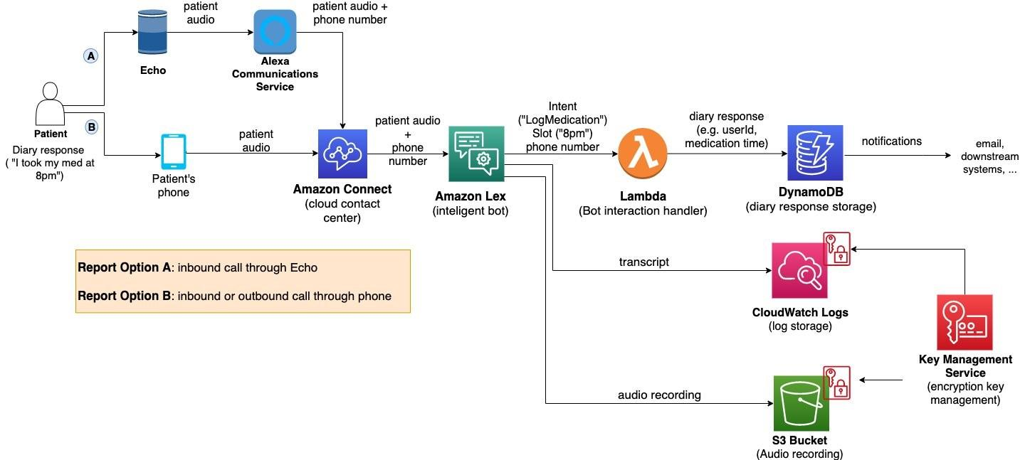

*Figure 1: Architecture and data flow of the voice patient diary sample application*

**Reference:** [**https://aws.amazon.com/blogs/industries/voice-applications-in-clinical-research-powered-by-ai-on-aws-part-1-architecture-and-design-considerations/**](https://aws.amazon.com/blogs/industries/voice-applications-in-clinical-research-powered-by-ai-on-aws-part-1-architecture-and-design-considerations/)